
Development Request
Aria Systems
Amend IC Pack screen

Program Add-in Template Description

Program Add-in Template

Program Add-in Header
Product: | Aria27
Module: | IC
Customer name: | Nik Nak Clothing
Installed Modules: | AL, AR, AP, IC, MA, PO, RM, SO, SR, SM,GL
Parameters setting: | Multi-currency, multi-location  Extended sizes = Yes  Style code structure 12-3-3  Characters for size scale code = 2

System Setting Report:

Details Section

Amend the Pack screen in IC as follows:-

Add a Flag in System Manager IC setup titled – Check Pack totals

If this field is set to yes, then the following processing should happen

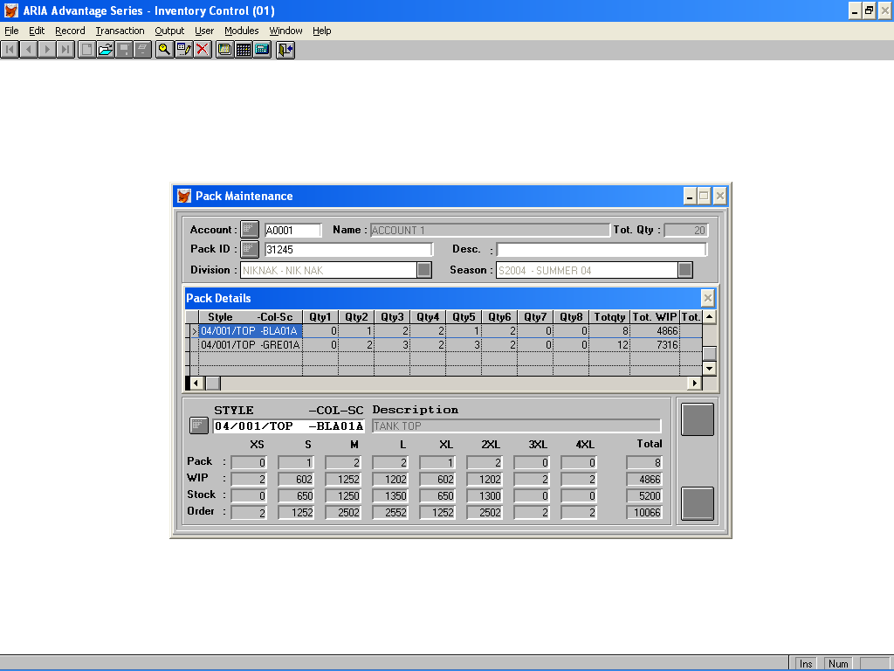

When the user adds the Pack Id, the user will then have access to the Tot. Qty field to key in a predicted total for the pack

When the user has keyed in all the style details in the pack and clicks on Save, the system checks if the predicted total agrees with the actual total entered. If not a message is displayed, ‘Qty entered 999 does not agree with the Pack total 999’. The user can then accept or Modify with Modify being the defaulted option. The user can then modify the pack breakdown and save again where the system checks again.

This option will not apply when editing a previously saved pack

